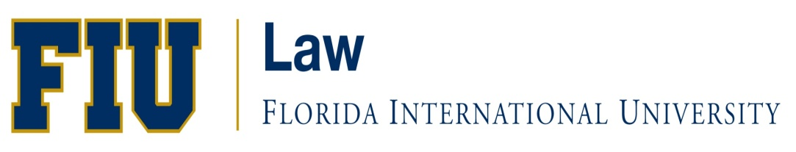

COLLEGE OF LAW

FALL 2020

JM

FIRST WEEK ASSIGNMENTS

LAW JRM 6300 RVC- Intro to American Law
Professors Margaret Correoso and Rima Mullins

First Week Assignment

- Read Chapter 1, pg. 1-22,
- Review web exercise question 2 (a)-(d), pg. 21,
- Review and analyze review questions 1-7, pg. 22,
- Be prepared to discuss the answers to the web exercise and review questions for the first day of class.

LAW JRM 6700 U20 – Torts and Criminal Wrongs
Professors Miriam Weismann

First Week Assignment

*READ THE SYLLABUS AND REVIEW “Course Content” ON Canvas
I. CIVIL WRONGS: TORT AND ADMINISTRATIVE LAW
CLASS 1 Corporate Existence and Liability: An Exercise in Legal Fiction and Self-Regulation
8/29
Topics: The legal attributes of a corporation; capital structure; types of securities: formal and functional characteristics; theories of corporate entity liability including respondeat superior, fiduciary duty and conflicts of interest; corporate legal privileges; and, the criminalization of corporate conduct.

Assignments:
text: Klein and Coffee, pp. 112-118; 122-27; 131-41; 177-185

canvas:
*Article: George Kuney, “Everything I Needed to Know About Enron I Learned in Kindergarten (and Graduate School)”
*read all case excerpts:
N.Y. Central and Hudson River R.R. Co. v. U.S.;
U.S. v. Bank of New England;
Upjohn v. U.S.; Braswell v. U.S;
Brown v. Wells Fargo

Note: Syllabus and other reading materials will be emailed to the students.
LAW JRM 6710 U20 - Legal Analysis and Writing
Professors Joseph Ankus

First Week Assignment

First Week Assignments will be emailed directly to students.

