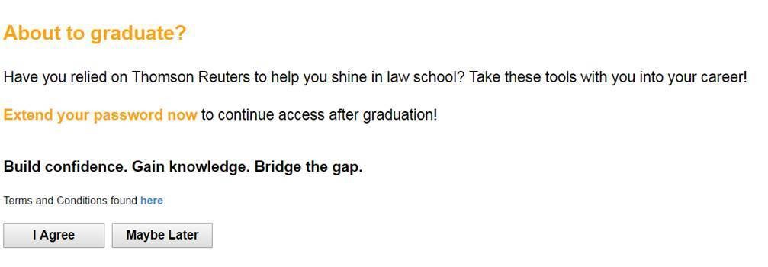
Not seeing the prompt?

- Use this link - https://lawschool.westlaw.com/authentication/gradelite

What do I get with my extended graduate access?

- Know How - Access to helpful sample documents and checklists with Practical Law & Practice Point
- Research - Westlaw access to understand the law and find authority
- Drafting Tools - Access to contract review, citation formatting and authority review tools with Drafting Assistant.
You will have 60 hours of access to the tools each month for the first 18 months from the date of your graduation, so be sure to extend today to maximize your benefits.
Extended access begins in the first month after graduation, so the sooner the extension, the longer the benefit. In other words, if the student waits 6 months to extend, they will only receive a 2-month extension.

