

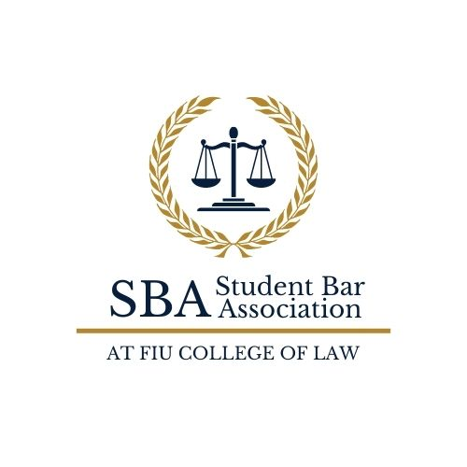

STUDENT ORGANIZATION EVENT PLANNING GUIDE

Step One: Check the SBA Monthly Calendar and FIU University Calendar of Events and Add Your Event

- SBA Monthly Calendar on SharePoint
  - Within the Student Organizations Folder, click the Full List of Events folder.
  - Click on the relevant semester and monthly calendar you plan to have your event.
  - Input your event title, the time of the event, and the room you would like to use into the list (RDB 2006, RDB 2005), keeping in mind that per SBA bylaws, no two events may take place on the same date at the same time, unless they are co-sponsored events taking place in the same location.
  - Please see special room request on page 9.
- To see events on the FIU University Calendar of Events
  - In the Search Bar, click on Departments and click on the College of Law.
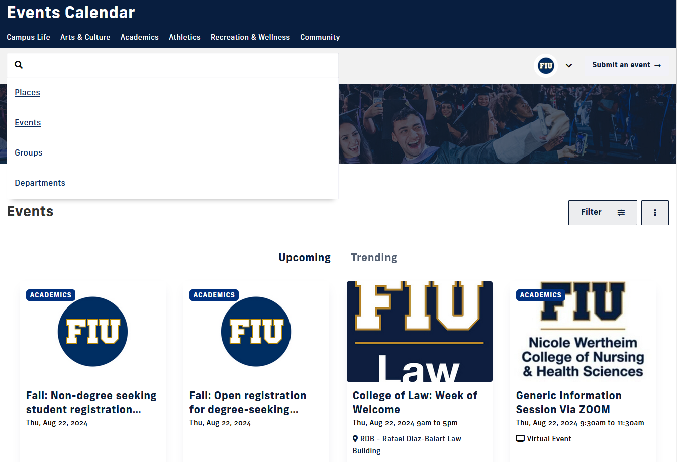
- To submit your event to the FIU University Calendar of Events
- Click on Log-In and log-in with your FIU credentials
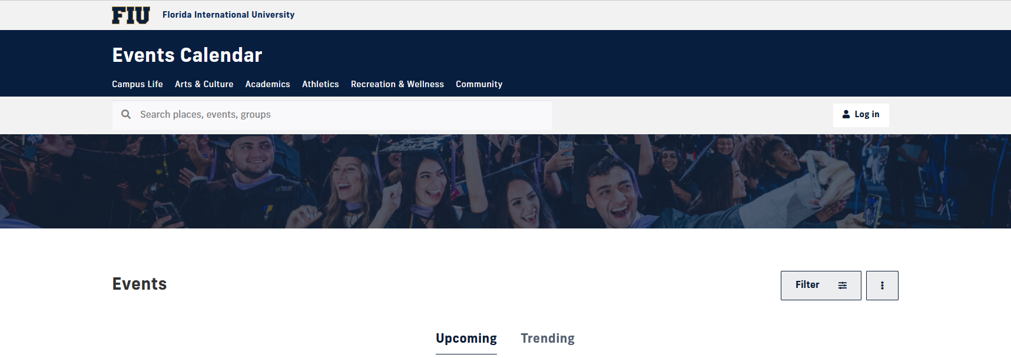

- This is what you should see. Your name should appear on the first line like this:
Florida International University > YOUR NAME’S DASHBOARD > Add an event
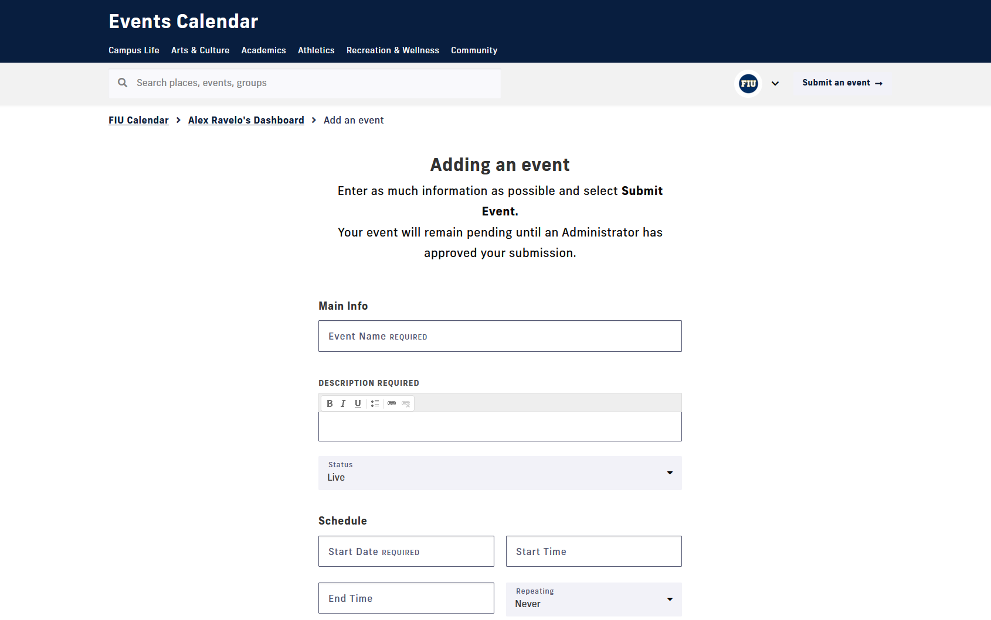

- Under Location – type Rafael Diaz Balart on the PLACE section
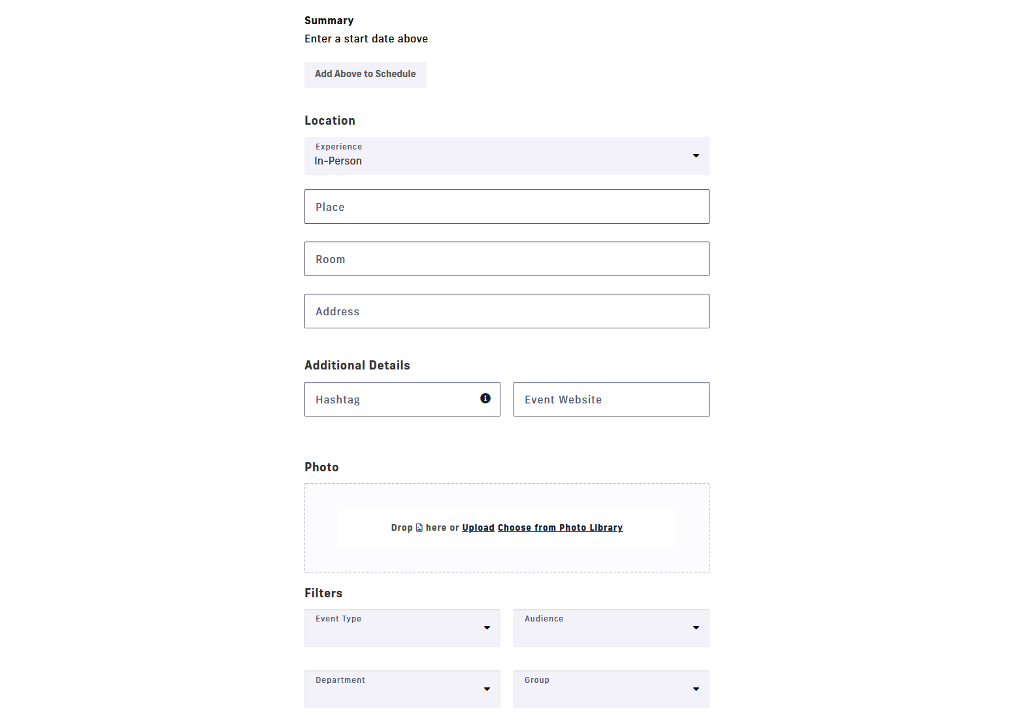

- Once your event info is all entered scroll down to ‘DEPARTMENT”. Make sure you select “College of Law”. This is the most important step. When you select the College of Law your entry will go to the approvers queue so it can be approved. Otherwise, COL approvers will not see it and it will go to the main university calendar manager.

- Your screen should look like this.
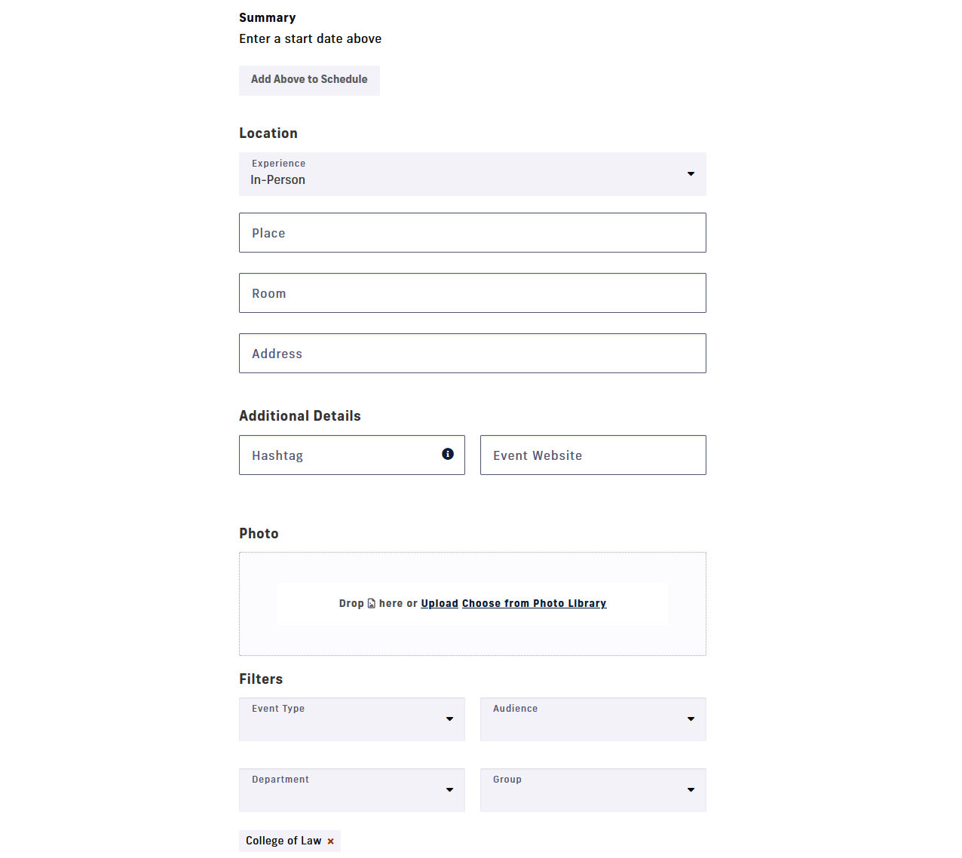
- Your screen should look like this. Click on Submit Event and you are done!!
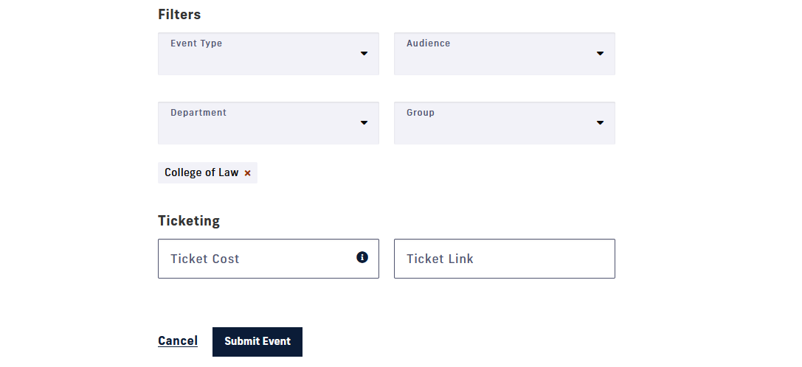

- Your screen should look like this after submitting.
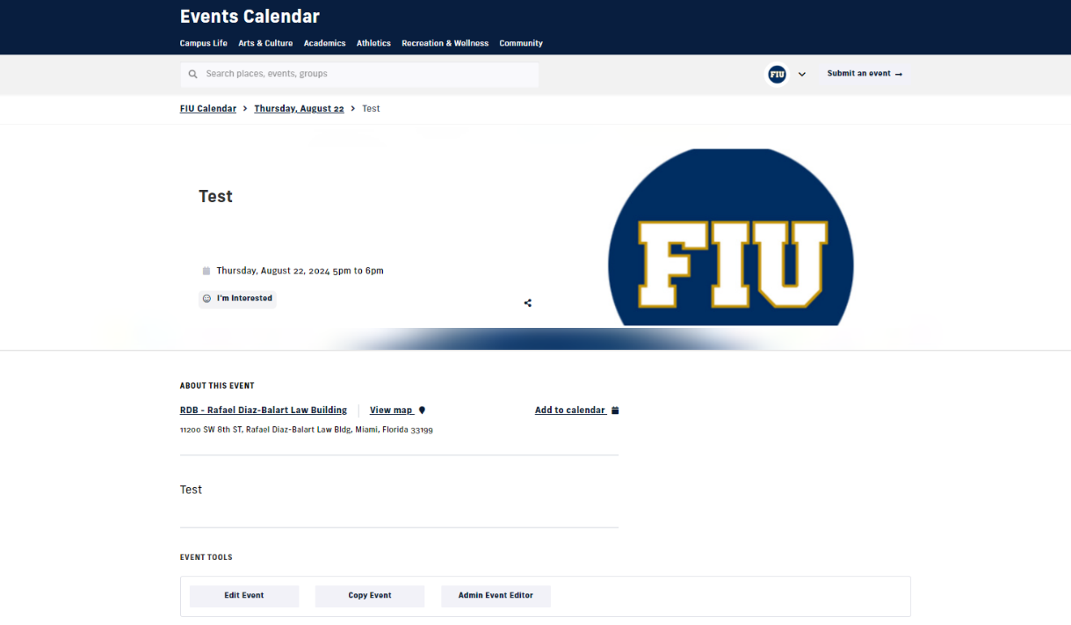

Note: Once approved you will receive an email. If you do not receive an email in 48 hours, please contact Student Services at lawstdsr@fiu.edu.

Step Two: Request Funding from the SBA

  - Complete an online SBA Funding Request Form. After clicking the link and reaching the FIU SBA website, scroll down to the bottom of the page till you find the Funding Request form shown below.
  - You cannot seek SBA funding after an event. FIU cannot, under any circumstances, reimburse students for expenses. You cannot contract with any vendor on behalf of your organization, FIU Law, or FIU. Only authorized FIU personnel may enter into contracts with vendors.
  - You must get quotes, estimates, and/or invoices from the vendors you are purchasing food or supplies from. Quotes and/or invoices should be uploaded to the SBA Funding Request Form.
  - Please ensure that the vendor does not include sales tax in its quote, estimate, or invoice. You may find a copy of FIU’s tax-exempt form in the SBA Student Organizations SharePoint folder.
  - A flyer for the event must be uploaded to this form.
  - Remember to include a $3 per guest parking pass if you will be having guest speakers coming to present in-person.
  - Please email Dean Ortega at afridman@fiu.edu and Student Services at lawstdsr@fiu.edu regarding any off-campus events or any events where you are hosting this event prior to submitting your funding request.
  - A representative of your student organization must attend the SBA Finance meeting, either in person or via zoom, to present the funding request.

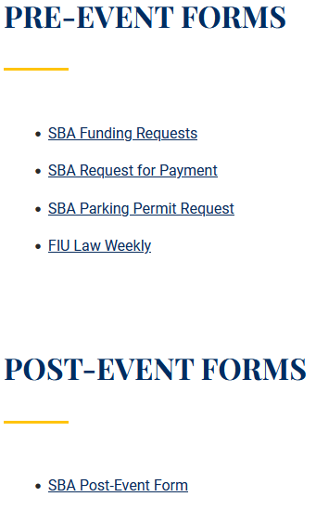
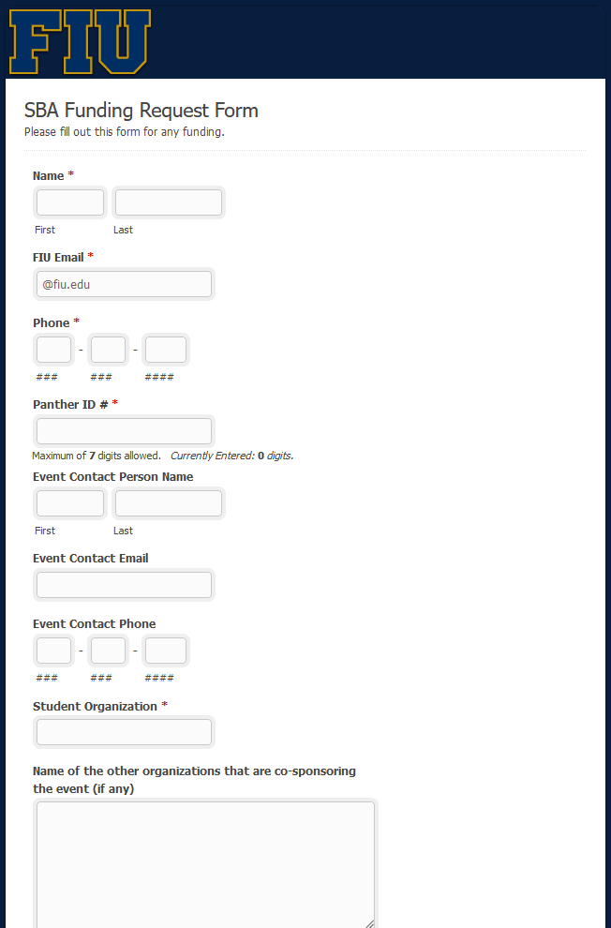

  - You must submit an SBA Funding Request and get approval from the SBA before your event according to the funding deadlines below:
Event date | Funding/Travel Request Deadline (at 11:59 PM)* | Travel/Departure date | SBA Meeting Date  (at 1:00 PM)
September 2, 2024 - September 23, 2024 | August 17, 2024 | September 18, 2024 – October 15, 2024 | August 21, 2024
September 24, 2024 – October 22, 2024 | September 10, 2024 | October 16, 2024 – November 12, 2024 | September 18, 2024
October 23, 2024 – November 18, 2024 | October 8, 2024 | November 13, 2024 – December 3, 2024 | October 16, 2024
November 19, 2024 – December 3, 2024 | November 5, 2024 |  | November 13, 2024

General Meeting at 1:00 P.M. | September 4, 2024
General Meeting at 1:00 P.M. | October 2, 2024
General Meeting at 1:00 P.M. | October 30, 2024
General Meeting at 1:00 P.M. | November 13, 2024

Step Three: Placing your Order
- Vendors will be paid based on the total approved by the SBA.
- It is the responsibility of the student organization to place the order with the vendor. Once the order has been placed, the student organization must submit a Request for Payment Form with payment instructions no earlier than two (2) business days before the day of the event and before 2pm the business day prior to the event.
- Amazon Orders: Please send the items titles and cost per item in the Request for Payment Form. Please anticipate delivery delays when placing.
- If your organization’s approved funding request included guest parking spaces, the requesting student organization must submit a Parking Permit Request Form with the name of the guest speaker(s) and their license plates. The guest speaker(s) may park in the blue spaces labeled Faculty/Staff or in any student space.

Step Four: Marketing Your Event
  - Event Flyer/Poster – Event flyer/poster are required for all events funded by the SBA, and it is the responsibility of each organization to create its own flyers. You may post your event flyers and posters in the display stands or pin boards within the law building. Your flyer must include “sponsored by SGA & SBA” or include the SGA & SBA logo.
    - Taping flyers to walls, windows, or doors is prohibited.
    - If you would like SBA to promote the event on its,
      - Instagram: please tag us @fiu_sba;
      - WhatsApp: please contact the SBA Secretary or Committee members of the Marketing Committee for assistance

  - FIU Law Weekly - You should advertise an event in the FIU Law Weekly newsletter. The FIU Law Weekly newsletter is sent out at the beginning of every week. The deadline for submitting student events is Friday at 12:00 noon by submitting the FIU Law Weekly Form.

Step Five: Manage Your Event

Pre-Event:

Should you need additional tables for your meeting/events, you may check out the SBA foldable tables at the Library Circulation Desk. Make sure you return them promptly after your event is over.

For large or special events requiring public safety, catering, table set-up, parking-space reservation, additional microphones, and/or other service contracts, you must make an appointment with the SBA and Student Services to help coordinate the event. The meeting must be made at least two weeks before the event. All special equipment, extra personnel, and parking-space reservations must be paid by the student organization and must be included in the student organization’s funding request in Step Two.

For university tables, there will be a fee involved and you must check with Student Services two weeks in advance.
- Special requirements for use of courtrooms: Please email the SBA President, at sbapres@fiu.edu, and SBA Secretary at sbasec@fiu.edu with your request. If approved, they will submit the room request on behalf of the requesting student organization.

You may purchase only Pepsi products for events due to FIU contractual obligations

Post-Event:

Please assist the custodial staff by making sure to leave the room tidy and by moving any leftover food to the Student Lounge.

Please make sure that you take down your flyers after your event is done.

You must submit the following:
  - Attendance/sign-in sheet: Example can be found on the SBA Student Organizations SharePoint folder.
  - The receipt(s) for anything purchased for your event with SBA funds, and
  - The flyer used to market your event.

Please submit all these materials via the SBA Post-Event Form within 48 hours of the event per SBA bylaws. Failure to comply may result in inactive status.

